**Assignment : 8**

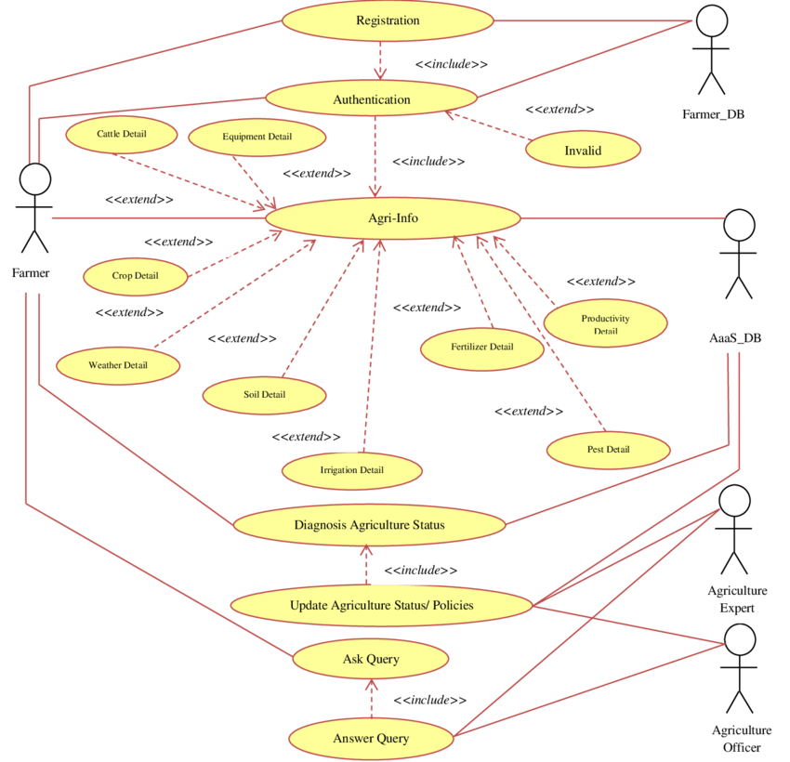

This is an UML case diagram for Agriculture based web application which shows many activities like show all information of pests and crops and government schemes.